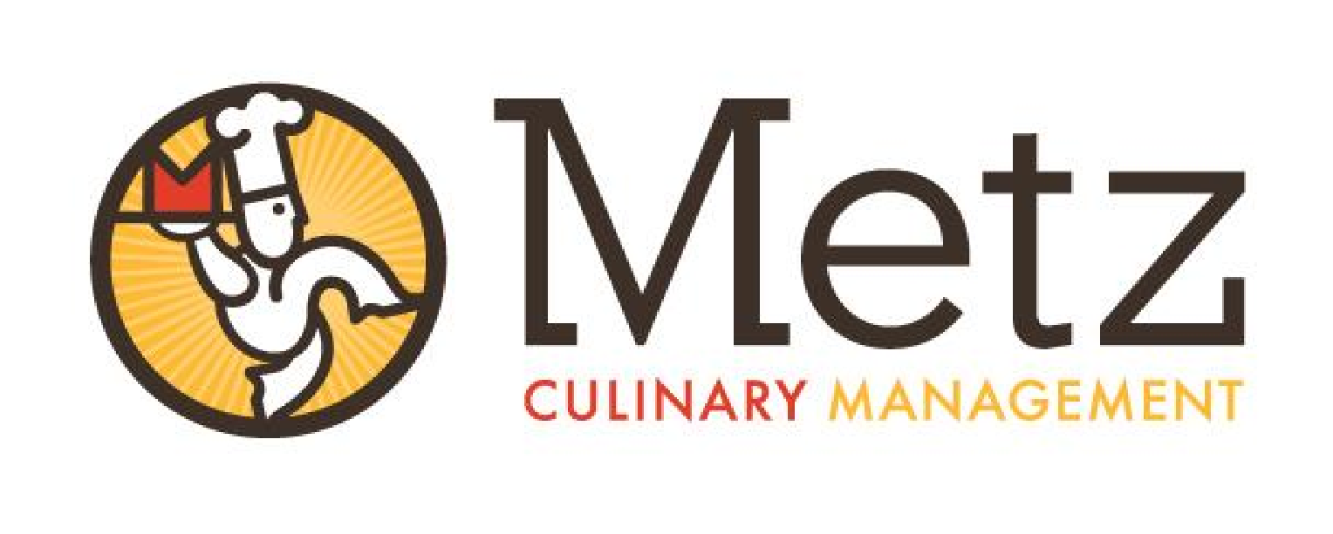

The new school year is right around the corner, and our team members at Metz Culinary Management are excited to welcome students back! You may have heard that the universal free meals program for breakfast has been approved by the state of Pennsylvania.

We are proud of our school lunches, and our culinary team continually adds new menu items that your student can find in their favorite restaurants. Popular selections include homemade mac n’ cheese, sweet and sour chicken, fresh dough pizza, walking taco, spicy chicken sandwich, and more.

We also offer an outstanding breakfast program for students. I highly encourage you to talk to your student about getting breakfast on a daily basis. They have the opportunity to come down to the cafeteria to get breakfast before or during homeroom. As the most important meal of the day, our culinary team creates breakfast menus that students are sure to enjoy while fueling their brains for learning.

School meals are a great value, especially with the rising costs of groceries and inflation. Your student will receive a well-balanced meal that meets nutritional guidelines established by the USDA, which offers a serving of fruit and vegetables daily, along with whole grains, lean proteins, and low-fat milk.

Those families who meet eligibility requirements based on income can apply for reduced-price or free meals. To receive an application or to inquire if your student qualifies for a free or reduced-price meal, please contact Cherie Kauffman at 570.345.2731, ext. 323.

Sincerely,

Bernie Kelly

General Manager

Metz Culinary Management

Pine Grove Area School District

Office: 570.345.2731 ext. 357

Metz Culinary Management Two Woodland Drive Dallas, PA 18612 570-675-8100